Ernie Studer School
Handbook
2026 – 2027
━━━━━━━━━━━━━━━━━━━━━
Creating a Foundation for a Lifetime of Learning
Empowering Students • Building Community • Inspiring Success

Northwest School Division #203

Table of Contents
- Introduction
- Staff List
  - Teaching Staff
  - Support Staff
  - Administration
- School Goals
- Daily Schedule – Bell Schedule 2026–2027
  - Elementary Schedule
  - Middle/High School Schedule
- School Expectations
- Rights and Responsibilities
  - Students
  - Teachers
  - Parents
- Attendance (AP 340)
- Inclement Weather (AP 133)
- Dress Code
- Student Health & Safety (AP 160)
- Student Records (AP 320)
- Support for Students with Intensive Needs (AP 210)
- Extracurricular Activities & Code of Conduct (AP 262)
- Available Activities
- Parent Volunteers
- Requirement for Criminal Record Check
- Permission Forms
- Communication
- Transportation (AP 551)
- Discipline Policy (AP 355)

Introduction
Ernie Studer School serves students in Kindergarten through Grade 12 as part of the Northwest School Division #203. This handbook provides students and families with an overview of our school’s programs, routines, and expectations. Student success is a partnership between home and school, and we encourage parents and guardians to communicate openly with staff.
Staff List
- Kindergarten / Grade 1/Grade 2 – Jeanelle Warner
- Grade 3 / Grade 4 – Tanya Conner
- Grade 5 – Jody Freyman
- Grade 6 / Grade 7 – Lori Sargent
- Grade 8 / Grade 9 – Rob Kozinski
- Grade 10 – Lori Bartee
- Grade 11 / Grade 12 – Daylene Morton
- Music and Following their Voices – Ben Giesbrecht
- Classroom Complexity and Student Services – Kim Arnott

Support Staff
- Secretary – Vanity Aschenbrenner
- Educational Assistant – Barb Albers
- Educational Assistant – Sam Cardinal
- Wellness Coordinator – Ashton Hein
- Librarian – Linda Baldwin
Administration
- Principal – Jon Kemp
- Vice Principal – Jody Freyman

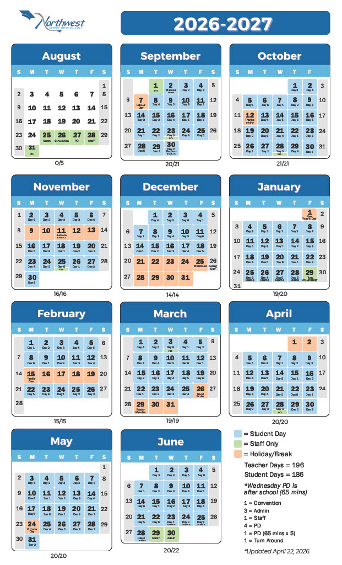

School Goals
2026-2027 Action Plan Goals
- Strengthening Attendance: Our school will improve attendance by launching a student mentoring and belonging initiative that pairs at-risk learners with trusted staff for regular check-ins, goal-setting, and encouragement to strengthen connection to school.

- Improving Reading and Writing: Our school will provide targeted instruction for students with reading difficulties through the implementation of OSR (Orchestrating Success in Reading). We will use assessment data from our June screens and work to provide whole group and small group instruction based on student need in our ELA instruction. We will progress monitor at risk students and will use the new provincial screening tools in Grades K-3 to assess students at risk for reading difficulties. We use both a push-in model and pull-out model to implement reading programming for at risk students.

- Assessment Practices: Our goal is to strengthen assessment practices by making expectations clear, ensuring feedback is timely, and using a balanced range of assessment methods to better support student learning. We will do this by having teachers post clear assessment plans, use consistent success criteria, and provide opportunities for students to improve their learning through feedback, relearning, and resubmission.

- Student Engagement: Our goal is to strengthen student engagement by expanding meaningful learning opportunities, including land-based learning, partnerships with local First Nations education systems, and access to flexible credit options such as volunteerism, special projects, and apprenticeship credits. We will also support student wellbeing and belonging through food programs that provide breakfast, snacks, and occasional lunches throughout the year, and by using the SRC to engage students in classroom teams that earn points toward prizes.

Daily Schedule – Bell Schedule 2026-2027
Elementary Schedule
- 8:53 – Homeroom Notice Bell
- 8:55 – O Canada and Announcements
- 9:00 – 11:00 – Classes (120 mins)
- 11:00 – 11:15 – Recess (15 mins)
- 11:15 – 12:16 – Classes (61 mins)
- 12:16 – 12:35 – Lunch Break
- 12:35 – 12:50 – Outdoor Play
- 12:50 – 12:55 – Homeroom
- 12:55 – 2:02 – Classes (67 mins)
- 2:02 – 2:17 – Recess (15 mins)
- 2:17 – 3:19 – Classes (62 mins)
- 3:19 – Dismissal

Middle/High School Schedule
- 8:53 – Homeroom Notice Bell
- 8:55 – O Canada and Announcements
- 9:00 – 10:02 – Period 1 (62 mins)
- 10:07 – 11:09 – Period 2 (62 mins)
- 11:14 – 12:16 – Period 3 (62 mins)
- 12:16 – 12:55 – Lunch Break
- 12:55 – 1:00 – Homeroom
- 1:00 – 2:02 – Period 4 (62 mins)
- 2:02-2:17- Recess
- 2:17 – 3:19 – Period 5 (62 mins)
- 3:19 – Dismissal

School Expectations
At Ernie Studer School, it is expected that students:
- Show respect for themselves, others, and property.
- Walk quietly in the hallways and use respectful voices.
- Play safely, take turns, and include others.
- Wear gym-appropriate footwear.
- Follow technology use policies responsibly.
- Represent the school positively in all settings.

Rights and Responsibilities
Students: Have the right to learn in a safe and respectful environment. They are responsible for attending regularly, following rules, and treating others kindly.
Teachers: Have the right to teach in a safe and respectful environment. They are responsible for preparing engaging lessons, providing fair assessments, and supporting students.
Parents: Have the right to expect quality education for their children. They are responsible for supporting learning at home, encouraging regular attendance, and partnering with the school.
Attendance (AP 340)
Regular attendance is key to success. Parents are asked to contact the school if a student will be absent. Extended absences should be discussed with teachers in advance to arrange learning materials. Attendance is tracked according to Northwest School Division procedures, and families will be contacted if patterns of absenteeism emerge.

Inclement Weather (AP 133)
During periods of inclement weather, the school will remain OPEN unless an emergency arises that forces its closure. Parents have the right to decide whether to send their children to school during these times. If you are choosing to keep your children at home, please call the school so we know they are safe. When buses do not run, the bus driver will inform their riders and the school that the bus is not running.
Dress Code
At Ernie Studer School, we value individuality, diversity, and respect. Our dress code is designed to give students the freedom to express themselves while ensuring a safe, welcoming, and distraction-free learning environment.
Clothing must not display:
- Profanity or discriminatory language
- References to drugs, alcohol, or weapons
- Sexual, violent, or hateful imagery
- Footwear must be worn at all times for safety.
- Special classes (e.g., Physical Education, Shop, Science labs) may require specific attire such as athletic wear, closed-toed shoes, or protective gear.
- Hats and head coverings are permitted as long as faces are visible and the items are not used in a way that disrupts learning or disrespects others.
Student Health & Safety (AP 160)
The safety of students is our top priority. If a student requires medical attention while at school, parents/guardians will be contacted immediately. In emergencies, staff may seek medical assistance and notify families as soon as possible. Parents are encouraged to update medical information regularly.
Student Records (AP 320)
Parents and guardians have the right to access their child’s educational records. Records are managed in accordance with Northwest School Division policies and transferred when students move to another school. Requests for access or updates should be directed to the school office.
Support for Students with Intensive Needs (AP 210)
Services for students with intensive needs are coordinated with the Northwest School Division Student Services team. Parents are involved in planning and decision-making to ensure appropriate supports are provided.

Extracurricular Activities & Code of Conduct (AP 262)
Students have opportunities to participate in a variety of activities including athletics, arts, intramurals, academic fairs, student leadership, and outdoor education. Participation builds teamwork, confidence, and school spirit.
Parents and guardians are reminded of the Extra-Curricular Code of Conduct, which includes respecting coaches and staff. Topics such as playing time, strategy, or individual athlete performance should not be discussed with coaches during or after games. Communication should occur through appropriate school channels.
1. Available Activities:
· Students have access to various recreational and educational activities like drama, sports, music, and other interest-based groups, depending on available resources and student interest.
2. Parent Volunteers:
· Ernie Studer School encourages and welcomes parent volunteers to assist in school activities and events, including house team events, sports tournaments, and track and field, as well as classroom functions such as assisting with administrative tasks, library duties, reading, support, sales, or attending school productions. The involvement of parent volunteers is valued and seen as a collaborative partnership in student education.
3. Requirement for Criminal Record Check:
· Volunteers who work with students without direct supervision by the Principal or a teacher must submit a current criminal record/vulnerable sector check to the Principal before engaging in any activity or supervision involving students.
4. Permission Forms:
· Some activities may require students to return signed parental permission forms.
· Students who fail to return these forms may not be allowed to participate in the activity.
These procedures support student engagement across activities while fostering an environment encouraging parent participation in school events. To prioritize student safety, volunteers working directly with students, unsupervised, must undergo a criminal record check before engaging in any student-related activities.
Communication
Families are encouraged to maintain open communication with the school. Weekly newsletters, Edsby updates, and the school website provide important information. Concerns should first be addressed with the classroom teacher, and if needed, with administration.
Transportation (AP 551)
Northwest School Division provides regular bus transportation for eligible students who register each year. Routes are assigned to ensure safe and efficient travel to and from school. Students are expected to follow the bus rules and show respect for drivers, fellow passengers, and property at all times. Unsafe or inappropriate behavior may lead to disciplinary action, including the loss of bus privileges. Parents and guardians are responsible for ensuring their child is ready on time and for communicating any changes in transportation needs with the school.
Discipline Policy (AP 355)
The Northwest School Division prioritizes safe, effective, and respectful learning environments for all involved parties—students, staff, parents, and the community. Their mission highlights the importance of a robust discipline policy that fosters accountability for actions. In alignment with this mission, Ernie Studer School has formulated a strong Discipline Plan rooted in cooperation and mutual respect among students, parents, and teachers, as outlined in the Rights and Responsibilities section of the Northwest School Division Discipline Policy. This plan aims to facilitate an effective education and cultivate a positive school climate through the following:
1. Growth: Discipline aims for positive outcomes and student development.
2. Positive Intent: It's rooted in positivity and respect.
3. Continuous Process: Focuses on teaching appropriate behavior and self-control continuously.
4. Learning-Conducive Atmosphere: Students deserve an environment supportive of learning.
5. Clear Expectations: Clear expectations lead to improved individual performance.
